***Computer Vision 2023 Project [SC] Handwritten Signature Identification and Verification***

**data preparation process:**

* **part1:**
* **For both steps 2 and 3 had the same data preparation phase.**

First, after downloading the data, we created 4 different folders. 2 folders for images which are “Train” and “Test”, these 2 folders contain all the persons with their images.

Also, there is “TrainCSV” and “TestCSV”, both contain an assembled version of all CSVs for each person with their images’ paths, class which is this picture belongs to who. Each person is encoded to a number, e.g., personA:0, personB:1 and so on.

A sample of the CSV file:



* **part2:**
* A sample of the CSV file:

**Brief description of the models and techniques used in each task:**

* **part1:**
* **For step 2:**

**"Bag of Words"** is a way to simplify object representation as a collection of their subparts for purposes such as classification.

First we use SIFT to extract features and descriptors for those features then we cluster them by KMeans and finally we use them with SVM model for classification

* **For step 3:**

For step 3, the same CNN model was used among each person which is equivalent to 5 models. Due to the images’ dimensions we had to build a fairly simple model. The last layer used sigmoid in order to predict whether it was real “0” or forged “1”. CNN layers do feature extraction from image’s pixels. Where earlier layers do some simple tasks like edge detection and late layers provide more complex extractions.

A CNN is a kind of network architecture for deep learning algorithms and is specifically used for image recognition and tasks that involve the processing of pixel data.

* **Part2:**

In Faster R-CNN the image is provided as an input to a convolutional network which provides a convolutional feature map. Instead of using selective search algorithm on the feature map to identify the region proposals, a separate network is used to predict the region proposals

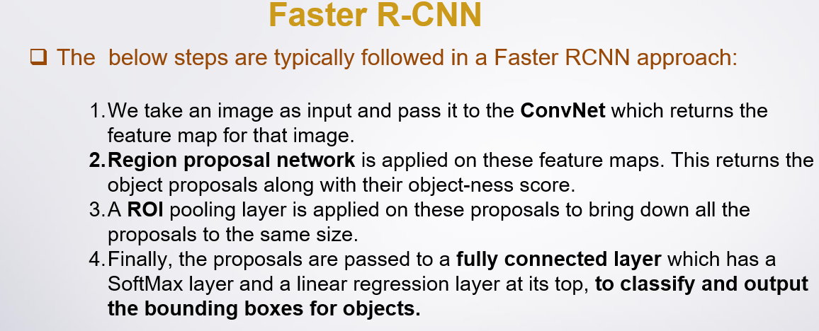

**Training and Testing times for each model:**

**Part1:**

* **For step 2:**



* **For step 3:**
  + **For person A:**



* + **For person B:**



* + **For person C:**



* + **For person D:**



* + **For person E:**



* + **For All Persons Together:**



**Image Classification training and testing accuracy:**

**Part1:**

* **For step 2:**



* **For step 3:**
  + **For person A:**

* + **For person B:**

* + **For person C:**

* + **For person D:**

* + **For person E:**

* + **For ALL Persons Together:**



**Provide screenshots of the test sets classification with visualization:**

* **Part1:**
* **For step 2:**

